Sodium (Na)
Atomic number – 11
Atomic weight – 23 amu
Electronic configuration – 1s² ,2s² ,2p⁶ ,3s¹

- Minerals of sodium ores of sodium
Sodium Chloride (NaCl) (Rock salt)
Sodium Nitrate (NaNO₃)
Borax (Na₂ B₄ O₇ * 10H₂ O)
Glauber’s salt (Na₂ SO₄ 10H₂ O)
- Extraction of Sodium
Sodium metal cannot be extracted by applying common method because of following reasons: -
(Difficulties of extraction of sodium)
- Sodium chloride has high melting point and thermally stable compound Therefore, Thermal decomposition method is impossible to extract sodium metal.
- The melting point of sodium chloride is 802 ̊ C. So, it is difficult to maintain.
- Chemical Reduction is impossible because at high temperature, Sodium reacts with carbon and Hydrogen to form carbide and hydride
- Electrolysis of aqueous solution of NaCl is impossible because of formation of Na⁺ and H⁺ ion during this process. Here, H⁺ ion has high reduction potential than Na⁺ ion. So, Hydrogen is collected at cathode instead of sodium.
In order to minimize these difficulties, chemist “Down” developed method to extract Sodium metal that is Down’s process.
Principle: In Down’s process, Sodium metal is extracted by the electrolysis of mixture of fused NaCl and CaCl₂ | CaF₂ at about 600̊ C
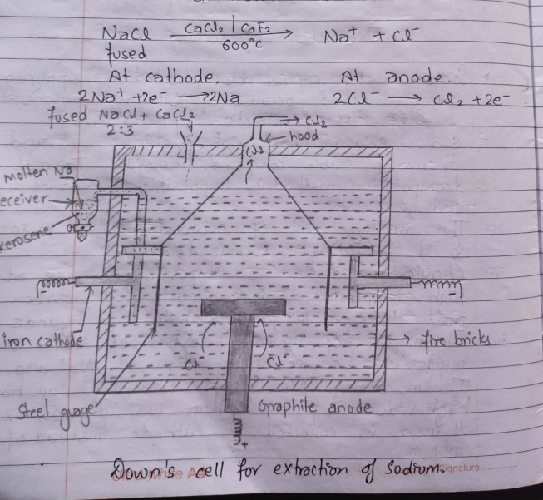

Working Process
It’s a cylindrical iron vessel lined with fire bricks. Carbon rod is placed at the centre of cell which acts as an anode. T-shaped iron rods act as a cathode. The steel gauge used in this process helps to separate electrolysed product.
The mixture of fused NaCl and Calcium Chloride (CaCl₂) in the ratio of 2:3 is taken in a cell / vessel. On passing to form ions, Sodium ions moves towards iron cathode to form molten sodium by reduction and being lighter rises up and collected in a vessel having kerosene oil. Similarly, Chloride ions move toward the graphite anode to form chlorine gas by oxidation and escape out through anodic hood.
Function of CaCl₂ | CaF₂.
CaCl₂ | CaF₂ is used during extraction of sodium in order to reduce system temperature from 802̊C to 600̊C which helps to minimize the following difficulties
- The melting point of sodium chloride is 802̊C which is difficult to maintain.
- At high temperature, sodium ions and chloride ions may react to form metallic fumes | fog
Physical Properties of Na
- It’s a slivery white soft solid.
- It has high melting point and boiling point
- It has high affinity towards oxygen, moisture and CO₂.
Chemical Properties of Na: -
- Action with moist air
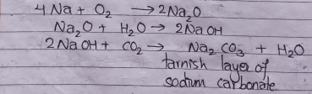
Sodium metal is highly reactive metal and reacts with oxygen, moisture and carbon dioxide
To form tarnish layer of sodium carbonate.
Therefore, it should be preserved under kerosene oil or non-polar solvent.

- Action with dry air.
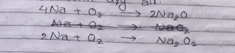
Sodium reacts with dry air to form sodium oxide and sodium peroxide.
Sodium oxide and sodium peroxide.

- Action with H₂O
It has high affinity towards oxygen.
Therefore, sodium metal reacts with water to form sodium hydroxide and hydrogen.

- Action with non-metals.
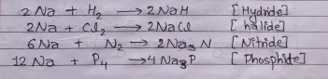
Sodium metal reacts with non-metal to form hydrides, halides, Nitrides, Phosphides, etc.

- Action with Ammonia (NH₃)
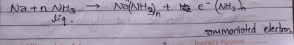
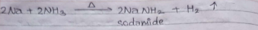
Sodium dissolves in liquid ammonia to form dark blue coloration of ammomated electron which has high conductivity but it gives sodamide at high temperature or on heating

- Action with Hg
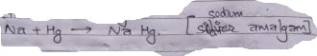
Sodium metal dissolves in Mercury to form Sodium amalgam.

- Action with CO₂
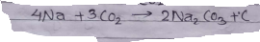
Sodium metal reacts with carbon dioxide to form sodium carbonate and carbon.
Therefore, Sodium fire cannot be extinguished by using CO₂ extinguisher.

- Action with ethanol.
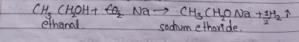
Sodium reacts with ethanol to form sodium ethoxide and hydrogen gas.

Uses of Sodium: -
- It’s used in sodium vapour lamp.
- It is used as laboratory reagent.
- It’s used form detection of foreign element present in organic compound.
- It’s used to prepare different compounds like sodamide.
- It’s used as reducing agent.
- It’s used as catalyst in the preparation of rubber
- Sodium foil is used in photoelectric purpose,

Note: Carbon tetrachloride can be used for extinguishing sodium fire.

Advantage of Down’s Process.
- It’s a simple technique
- Initial material i.e., NaCl is cheap and easily available.
- Chloride gas is obtained as a valuable by products.
- Impure NaCl can be used.
Compounds of Sodium.
- Sodium Hydroxide (NaOH) caustic soda.
- Sodium carbonate (Na₂CO₃)
Sodium Hydroxide
It is the compound of sodium and also known as caustic soda because aqueous solution of sodium Hydroxide has soapy touch but it is highly corrosive to skin, eye, cell membrane as well as glass surfaces so, it should be handled carefully.
Physical properties: -
- It’s highly soluble in water.
- It’s deliquescent compound.

Chemical Properties: -
- Precipitation reaction
- With CuSO₄
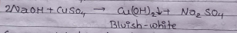
Cupric sulphate dissolves in sodium Hydroxide to form bluish-white or green ppt of cupric hydroxide and it gives black oxide of copper on heating
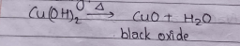

- With Ferrous and Ferric salt.
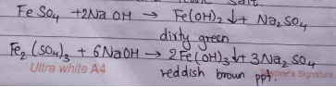
Ferrous sulphate forms dirty green ppt with concentrated sodium hydroxide but ferric sulphate forms reddish brown ppt.

- With Chromic salt.
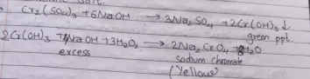
Chromic sulphate forms green ppt with NaOH but with excess NaOH and H₂O₂ Sodium Chromate is formed.

- With Aluminium and Zinc salt
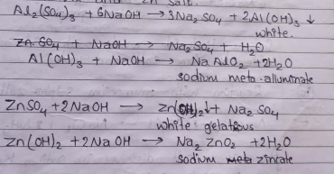
Salts of aluminium and zinc dissolves in aqueous solution of sodium Hydroxide to form white ppt of metallic hydroxide. The ppt obtained will dissolve in excess NaOH solution to form soluble complex.

- Reaction with CO.
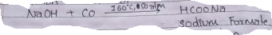
Sodium Hydroxide reacts with carbon monoxide at about 160̊C temperature 50 atmospheric pressure to form sodium formate.

- Basic Nature.
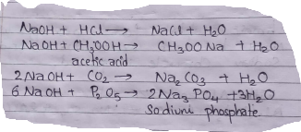
Sodium Hydroxide reacts with acid and acidic oxide to form salt and water.

- Reaction with ammonium salt.
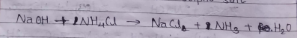
Ammonium salt dissolves in sodium hydroxide to from ammonia gas.

- Reaction with Amphoteric elements
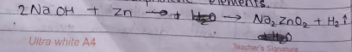
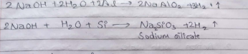

Uses of NaOH
- It’s used in cosmetics
- It’s used in antipyretic medicines.
- It’s used in food preservation.
- It’s used as lab reagent.
- It’s used in industrial manufacturing.
- It’s used cleaning agents
- It’s is used for mercerizing cotton.

Na₂CO₃(Sodium carbonate)
It exists in different form: -
- Na₂CO₃ -> light ash
- Na₂CO₃* H₂O -> heavy ash
- Na₂CO₃* 10H₂O -> Washing Soda
Physical Properties: -
- It is a white crystalline solid and soluble in water
- It is an efflorescent compound.

Chemical Properties
- On heating decahydrate salt, it gradually loses water to give anhydrous salt. The anhydrous sodium carbonate is called soda ash.
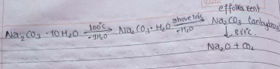

- Action with water.
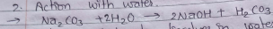
Sodium carbonate dissolves in water to form acid and base.

- Action with acid
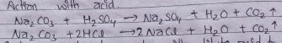
Sodium carbonate reacts with dilute acid to give CO₂ gas.

- Action with CO₂
Solution of sodium carbonate with carbon dioxide gives sodium bicarbonate (Baking Soda).

- Action with SO₂
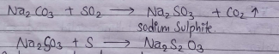
Sodium carbonate reacts with SO₂ gas to form sodium sulphite, when the aqueous solution of sodium sulphide is heated with sulphur powder to form sodium thiosulphate (hypo) which is used in photography print.

- Precipitation of salt of Pb, Mg, Zn, etc
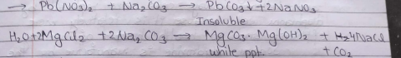
Sodium carbonate reacts with salt of different metal to form water insoluble metallic carbonate.

- Action with Al³⁺ and Fe³⁺
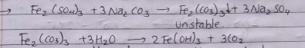
Aluminium salt and Iron salt dissolved in aqueous solution of sodium carbonate to form unstable respective carbonate and finally converted into metallic hydroxide.

Uses of Na₂CO₃
- It is used as a laboratory reagent.
- It is used for the manufacture of sodium silicate (Na₂SiO₃) (Water glass)
- It is used for softening water.
Modern chemical Manufacture
The mercury cathode cell i.e., caster keller and kellener solvay cells are replaced by diaphragm cell because it’s relatively more efficient and no health hazard of mercury.
Sodium Hydroxide is manufacture by electrolysis of brine (Aqueous s solution NaCl) in Nelson’s cell.
Here, Sodium hydroxide solution is produced at cathode compartment and concentrated to get 50% NaOH
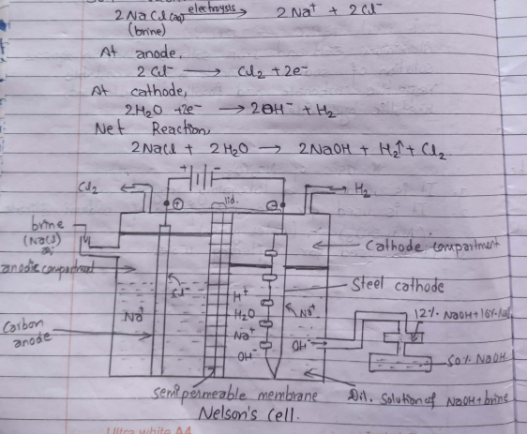

Working process
The saturated brine is taken in an anode compartment of nelson’s cell which is made up of refractory material. It contains carbon anode and stell cathode. It’s divided into tow parts i.e., Anodic Compartment and Cathode compartment.
When DC current is supplied Cl₂ gas is obtained at anode and H₂ gas cathode compartment as a by-product and they escape out from the top of the compartment. Here, sodium Hydroxide is produced at cathode compartment.
The Diaphragm helps to separate hydrogen and chloride at the same time, it reduces the chlorine at the same time, it reduces the chance of OH⁻ ions produced at the cathode compartment to mix with chlorine at anode compartment and increases the flow of Na² ions towards cathode compartment as well as reduced the flow of OH⁻ ions toward the anode compartment So, the label of solution at anode is always kept higher than that in cathode.
Therefore, it reduced the chance of side reactions.
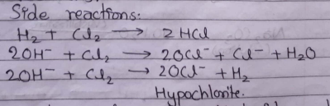
The mixture of sodium hydroxide produced at cathode after electrolysis of saturated brine contains 12% NaOH and 16% NaCl. The resulting mixture is transferred into another tank where sodium hydroxide is concentrated to 50% by heating with steam.

Manufacture of Sodium Carbonate by ammonia soda process or Solvay process.

Principle: Sodium carbonate is the important carbonate of the metal. It’s is manufactured by ammonia soda process.
When carbon dioxide gas is treated with Saturated bine solution in the presence of ammonia to form sodium bicarbonate. The ppt of sodium bicarbonate. Washing soda can be crystallized out from sodium carbonate solution.
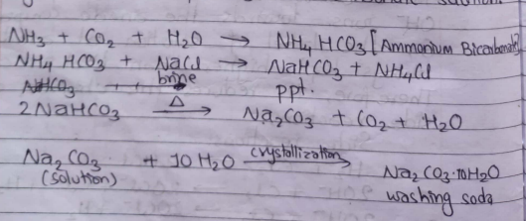
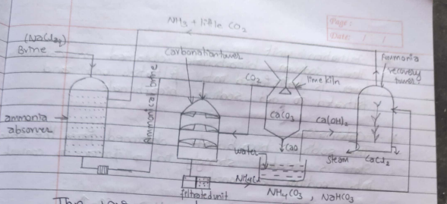
The various part of solvay process for the manufacture of sodium carbonate have been illustrated in figure
- Ammonia Absorber
A 30% solution of brine is saturated with ammonia. Different impurities like calcium and magnesium salt are precipitate as a carbonate.
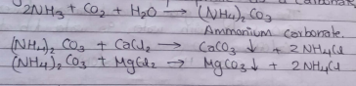

- Carbonation tower.
In this tower, Ammoniated brine solution is reacted with CO₂ gas which is produced lime kiln. Ammoniated brine and CO₂ combine to get Ammonium bicarbonate further react with bine solution to form sodium bicarbonate which is insoluble due to the presence of brine.
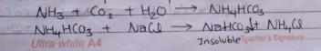

- Filtration unit
The sodium bicarbonate obtained in carbonation tower is transferred into filtration unit and filtration to get sodium bicarbonate.

- Calcination
The sodium bicarbonate obtained from the above state is heated strongly in a furnace to convert into sodium carbonate.
2NaHCO₃ CaO + CO₂
Sodium carbonate
- Lime tower| kiln
In lime tower, lime is heated at about 1000̊C to obtain CaO and CO₂
CaCO₃ CaO + CO₂

The CO₂ gas goes to carbonation tower but CaO react with water in water tub to form
Ca(OH)₂

- Ammonia Recovery tower
The filtrated after removal of sodium carbonate contains ammonium salt such as NH₄HCO₃, NH₄Cl. The filtrate is mixed with Ca (OH)₂ and is heated with steam in ammonia recovery tower.
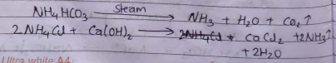
The mixture of ammonia and CO₂ gas is used for saturation of brine solution while CaCl₂ is obtained as a by-product.

Questions: -
- K₂CO₃ can not be extracted by Solvay process, why?
- Solvay process cannot be used for the manufacture of K₂CO₃ because potassium bicarbonate is highly soluble in water and doesn’t precipitate in carbonation tower.

- What happen when

- A small piece of sodium is dropped in water
- When a small piece of sodium is dropped in water sodium Hydroxide is formed.
2Na + H₂O ----- 2NaOH + H₂

- A piece of Aluminium is boiled with caustic soda solution?
- 2Al + 2H₂O + 2NaOH -- 2NaAlO₂ + 3 H₂

- Caustic soda solution is added to zinc sulphate solution drop by drop till excess.
- 2NaOH + ZnSO₄ -- Na₂SO₄ + Zn (OH)₂
- Zn (OH)₂ + 2NaOH -- Na₂ZnO₄ + H₂O
Sodium zincate

